**Packaging and Deploying WebJobs**

Using Visual Studio 2013 and the Azure SDK 2.4 or later, you can package a WebJob console application and deploy it without leaving Visual Studio.

While it can be convenient to deploy a WebJob alongside a web project (for example, an ASP.NET Web Application), this makes it difficult to scale the WebJob independently of the website and also introduces the potential for resource contention between the website handling requests and the WebJob performing its processing. Additionally, within a Visual Studio solution, it is possible to associate a WebJob with a web project at a later time if you consolidate the deployment. Therefore, it is pragmatic to start your WebJob development as a standalone console project.

1. Open the project you created previously in the section “Writing WebJobs using the SDK.” (first sample)
2. In Server Explorer, right-click the project and select Publish As Azure WebJob.

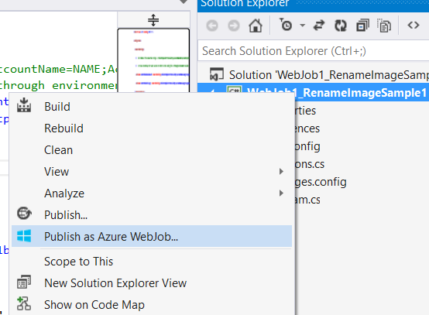

1. In the Add Azure WebJob dialog box, set the WebJob run mode to Run Continuously, and then click OK.

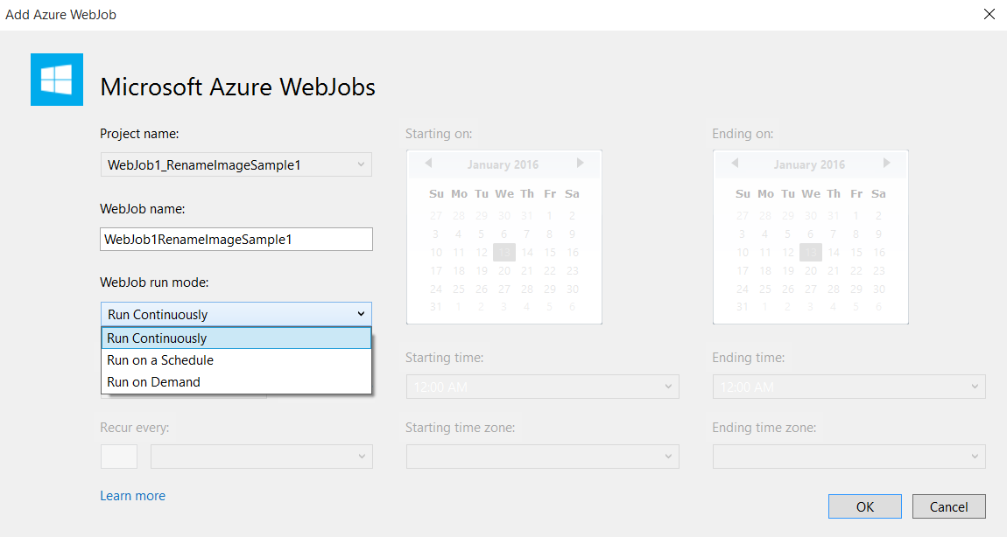

1. In the Publish Web dialog box, select “Microsoft Azure Web Apps” as your publish target.

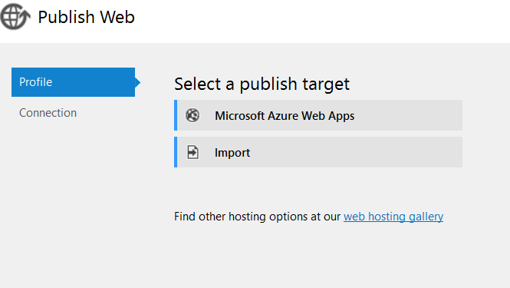

1. In the dialog box that appears, sign in if you have not done so already, and then click New to create a new website for this WebJob.

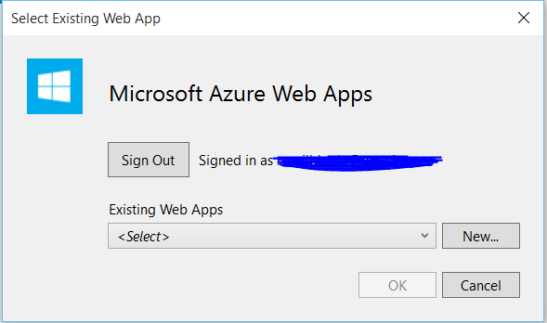

1. In the Create A Site On Microsoft Azure dialog box, provide a site name for the new website, and then specify a subscription and region as desired.
2. Click Create.

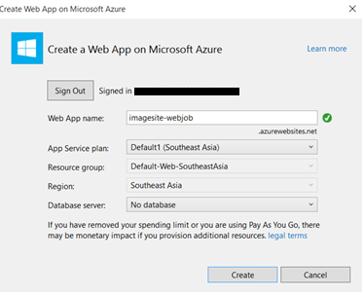

1. Return to the Publish Web dialog box, and click Publish to deploy your WebJob.

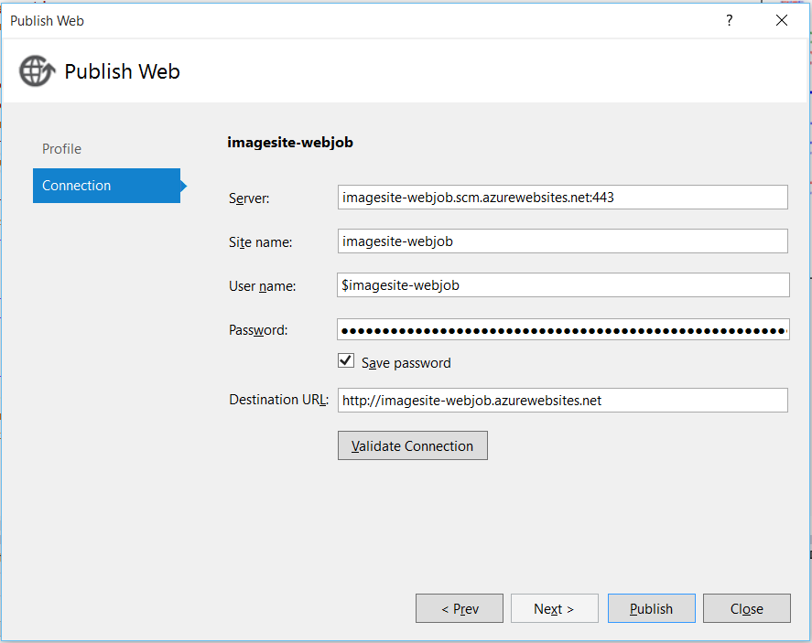

1. Before your WebJob will run, you need to navigate to the website you just created using the portal or from visual studio and add the same two connection strings (AzureWebJobsStorage and AzureWebsJobsDashboard) you previously added to App.config.

9A) Open Azure Portal & click on webapp name

Select “Configure” tab

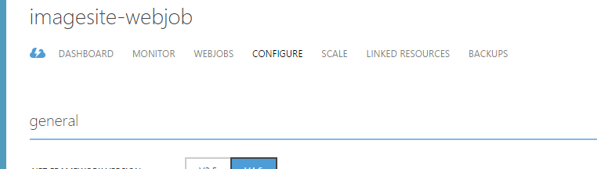

Scroll down “Configure” options

9B) Copy & Paste both ConnectionStrings & Click on Save button

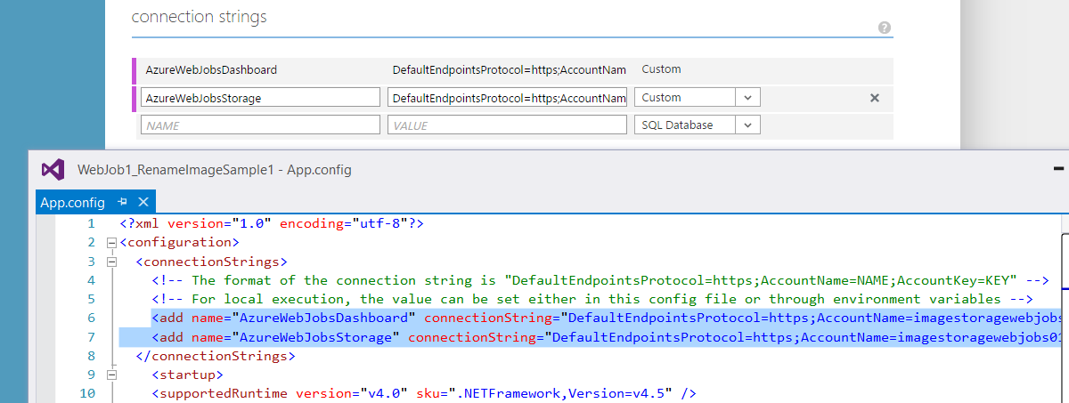



1. After you apply the connection strings, upload some .png files to the input folder.
2. Check on the status of the WebJob by using your browser to navigate to the Azure WebJobs Dashboard (which is a special WebJobs area within SCM), located at *https://<yourwebsitename>.scm.azurewebsites.net/azurejobs*.

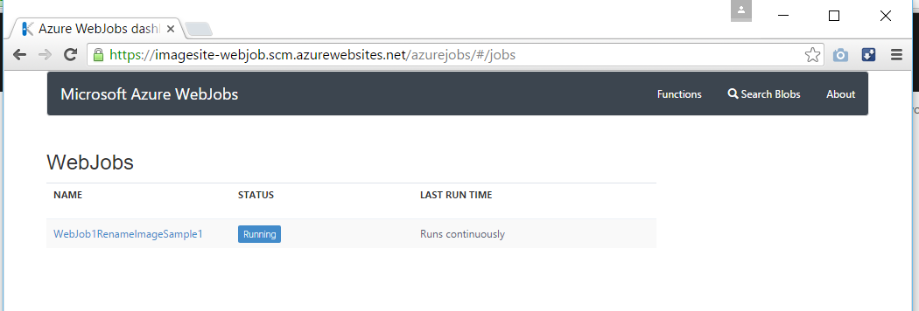

Run the program from Visual Studio

